**BABY CLASS LESSON NOTES FOR SOCIAL DEVELOPMENT**

**Term I, 2020**

WK 2

PD 1

Activities

Listening

Answering

Content

Story telling about people

I play and work with.

PD 2

People found at home.

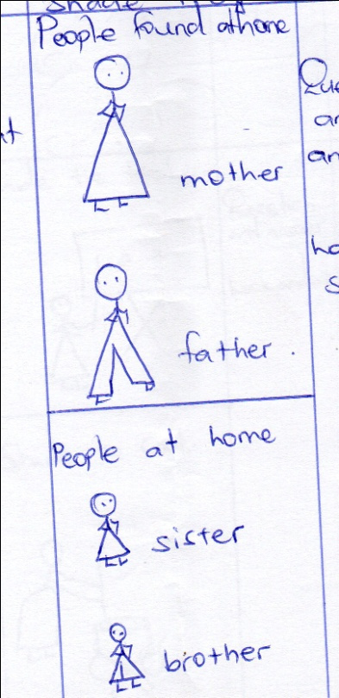

mother

father

WEEK 3

PD 1

I can mention people at home.

Content

Shade these people at home.

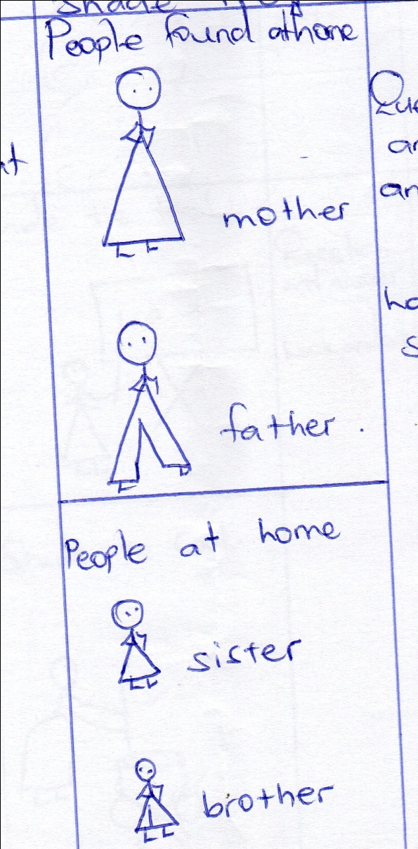

sister

brother

PD 2

I can trace and shade.

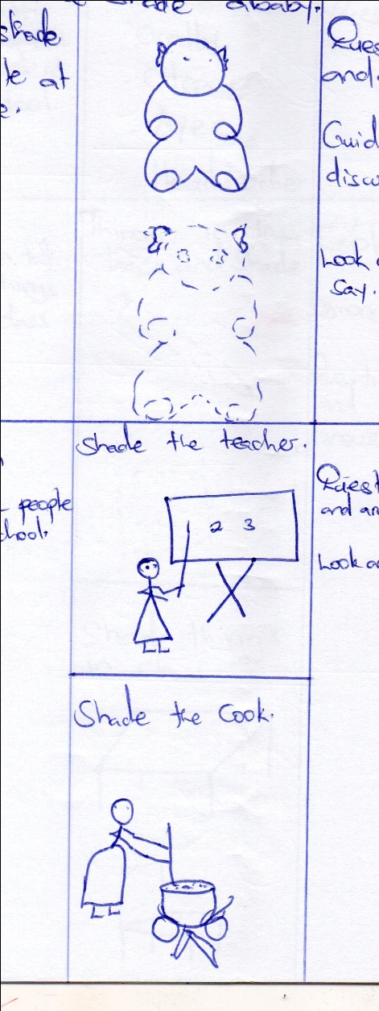

WEEK 4

PD 1

I can tell people at school.

Content

Shade the teacher.

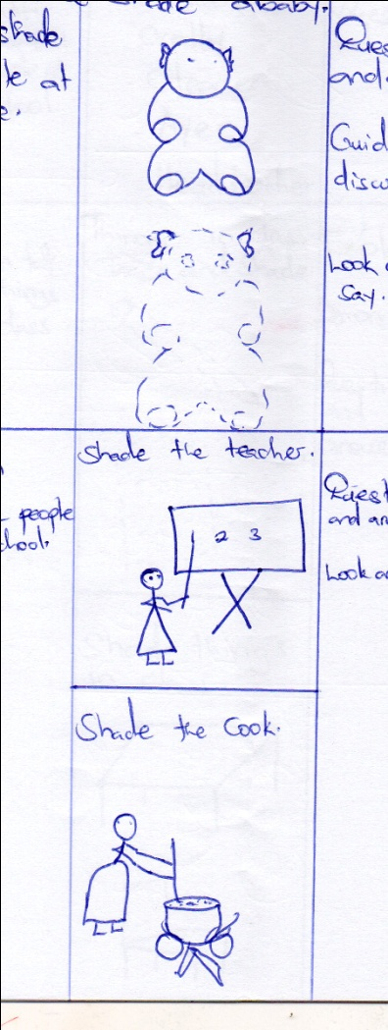

PD 2

I can tell people at school.

Content

Shade a cook.

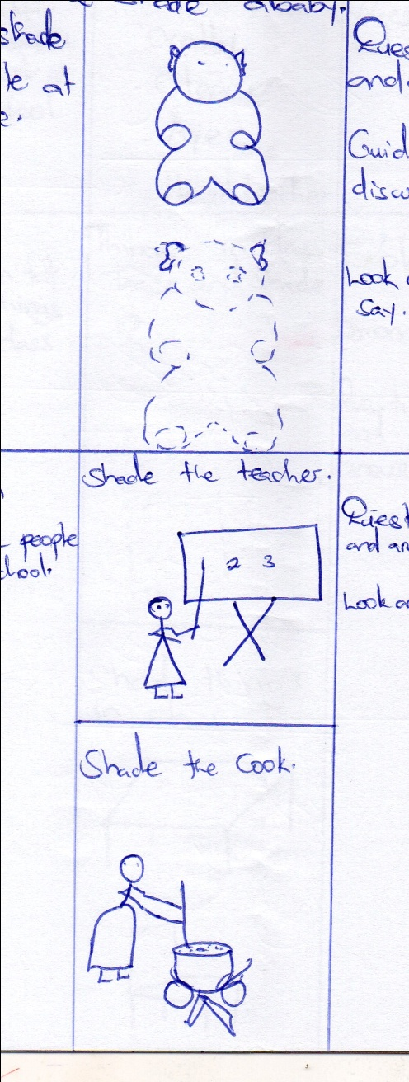

WEEK 5

PD 1

I can tell other people at school.

Content

Naming the people at school orally.

* cook
* cleaner
* aye
* headteacher

PD 2

I can talk of things in my class.

Trace and shade these things in class.

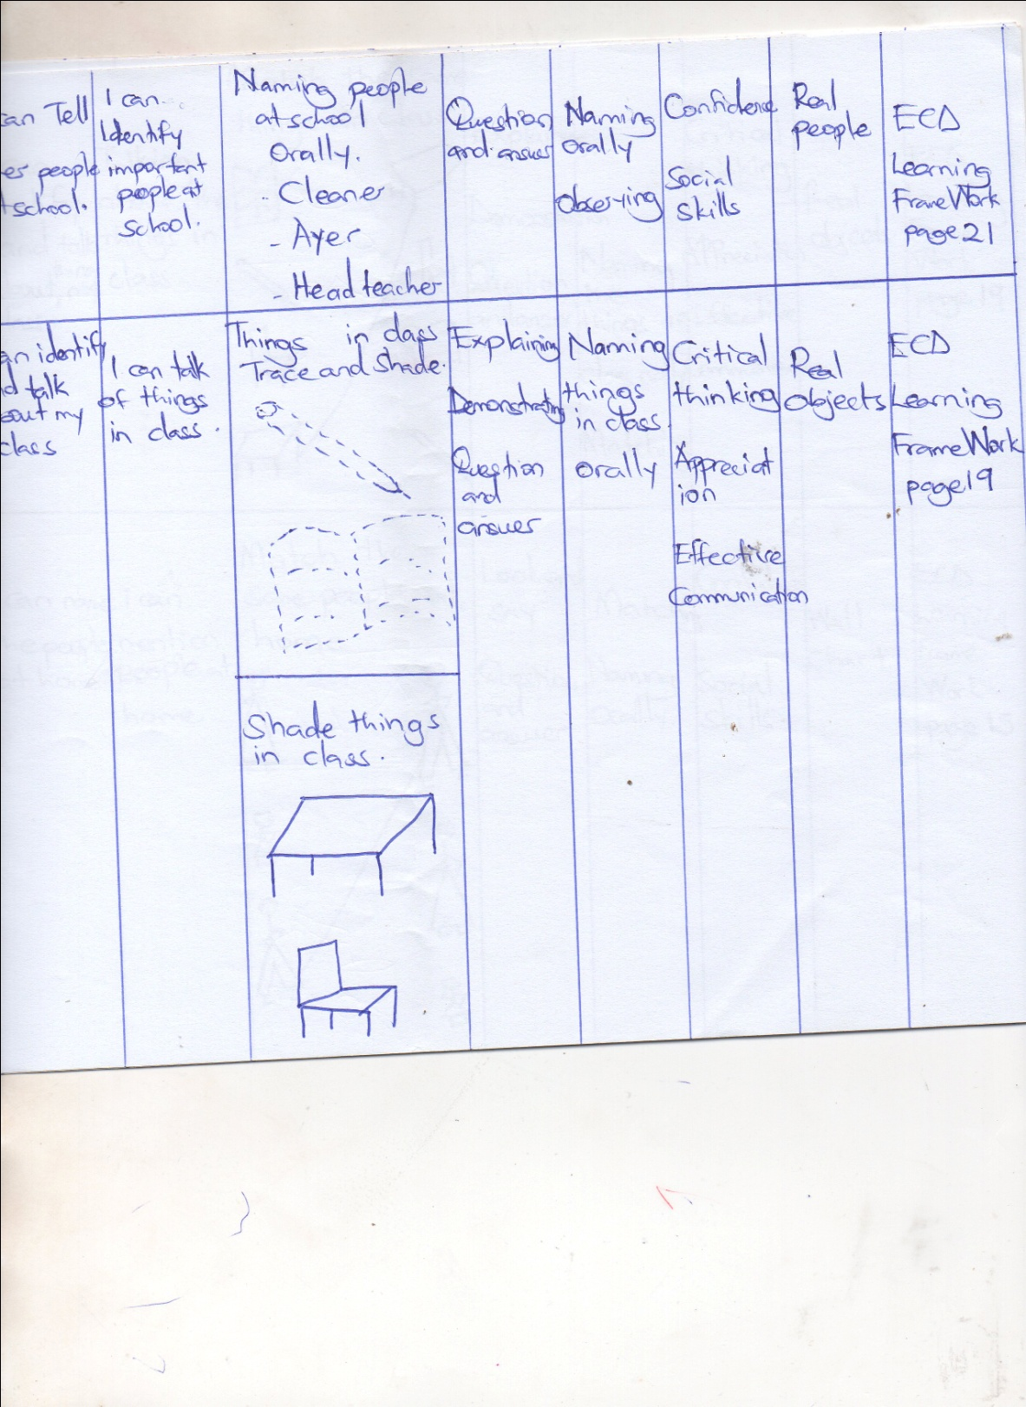

WEEK 6

PD1

I can talk about things in my class.

Content

Shade a table and a chair.

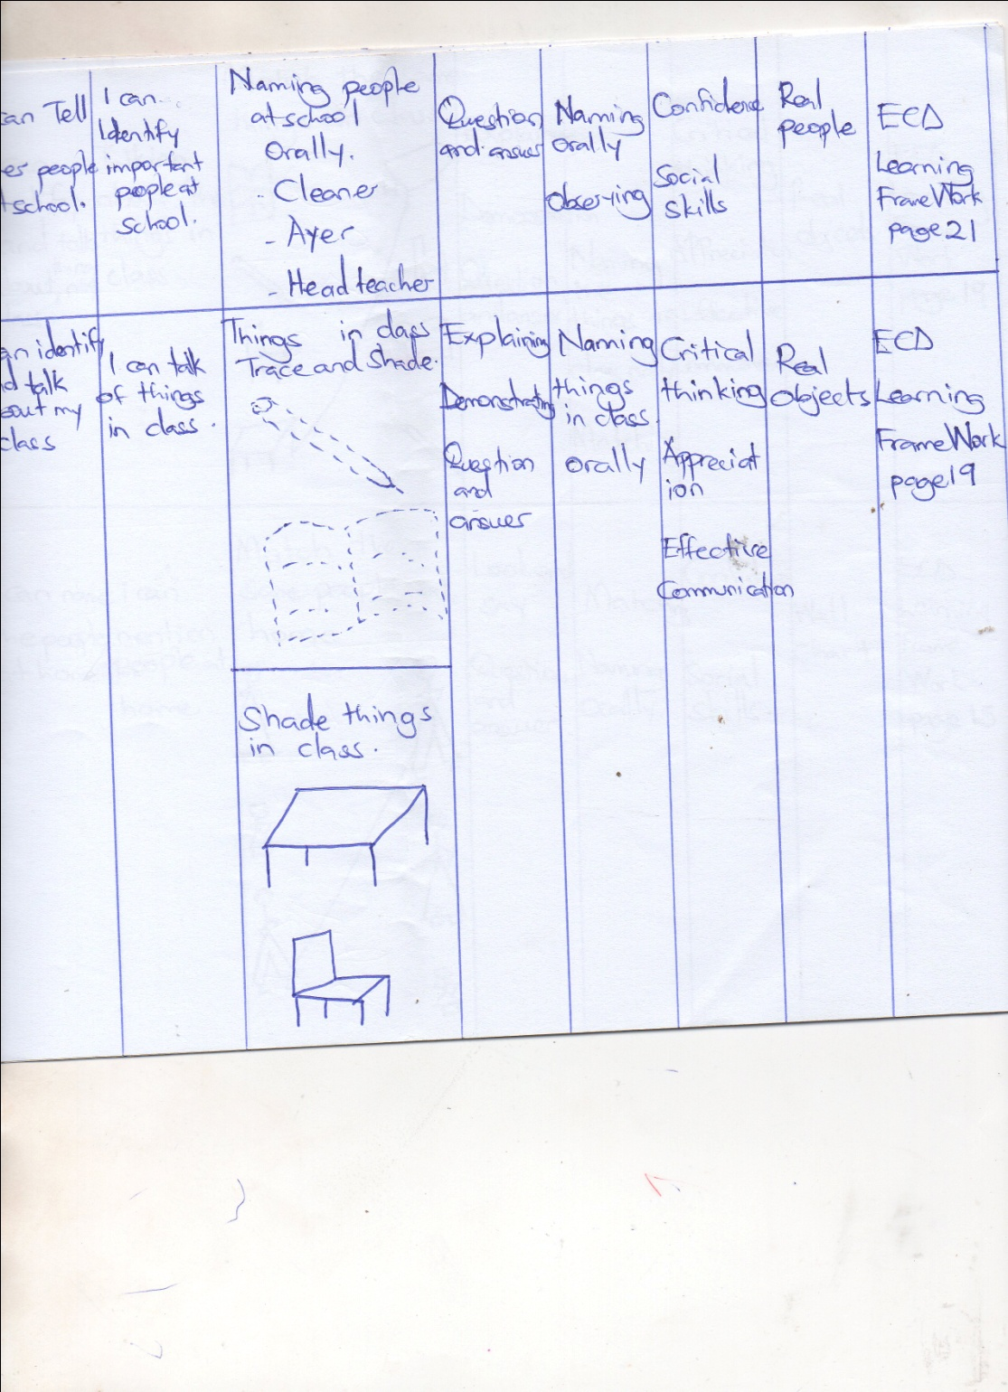

PD 2

I can identify and talk of things in class.

Content

Match the same things in class.

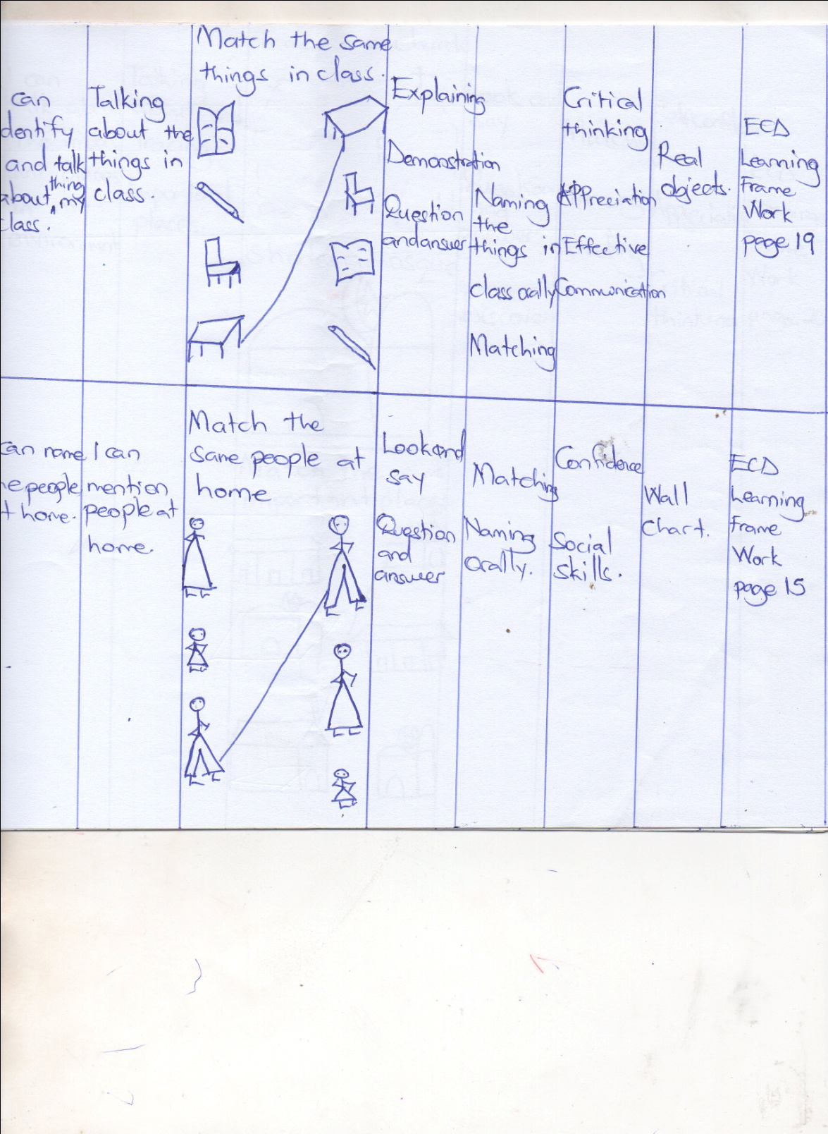

WEEK 7

PD 1

I can mention people at home.

Match the same.

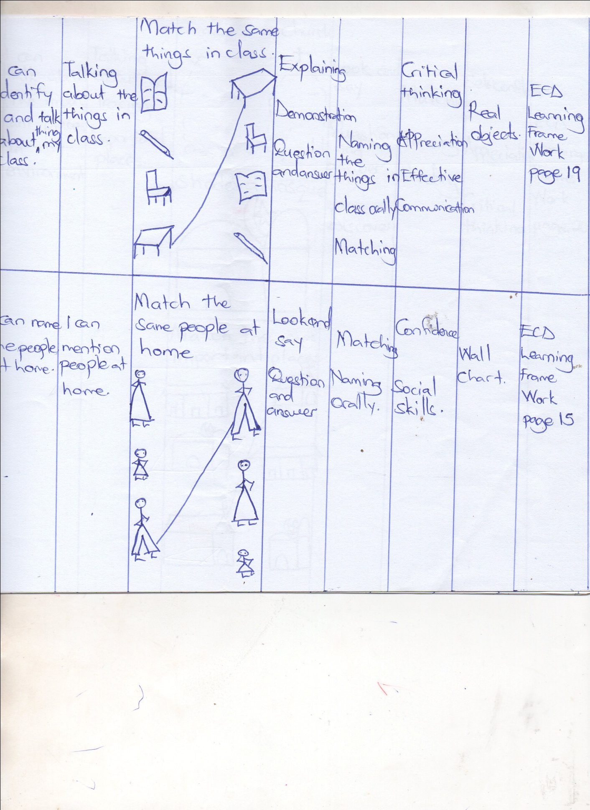

PD 2

I can talk about important places.

Trace a church.

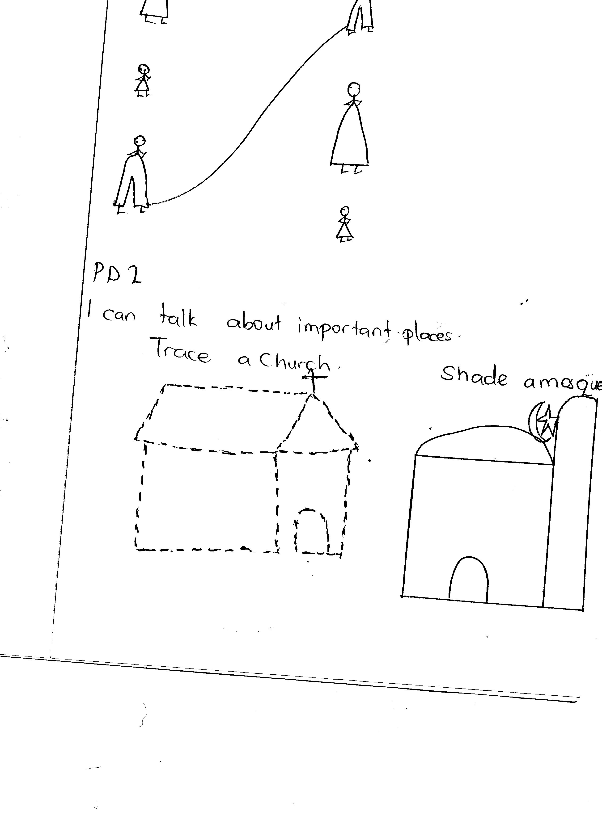

Shade a mosque.

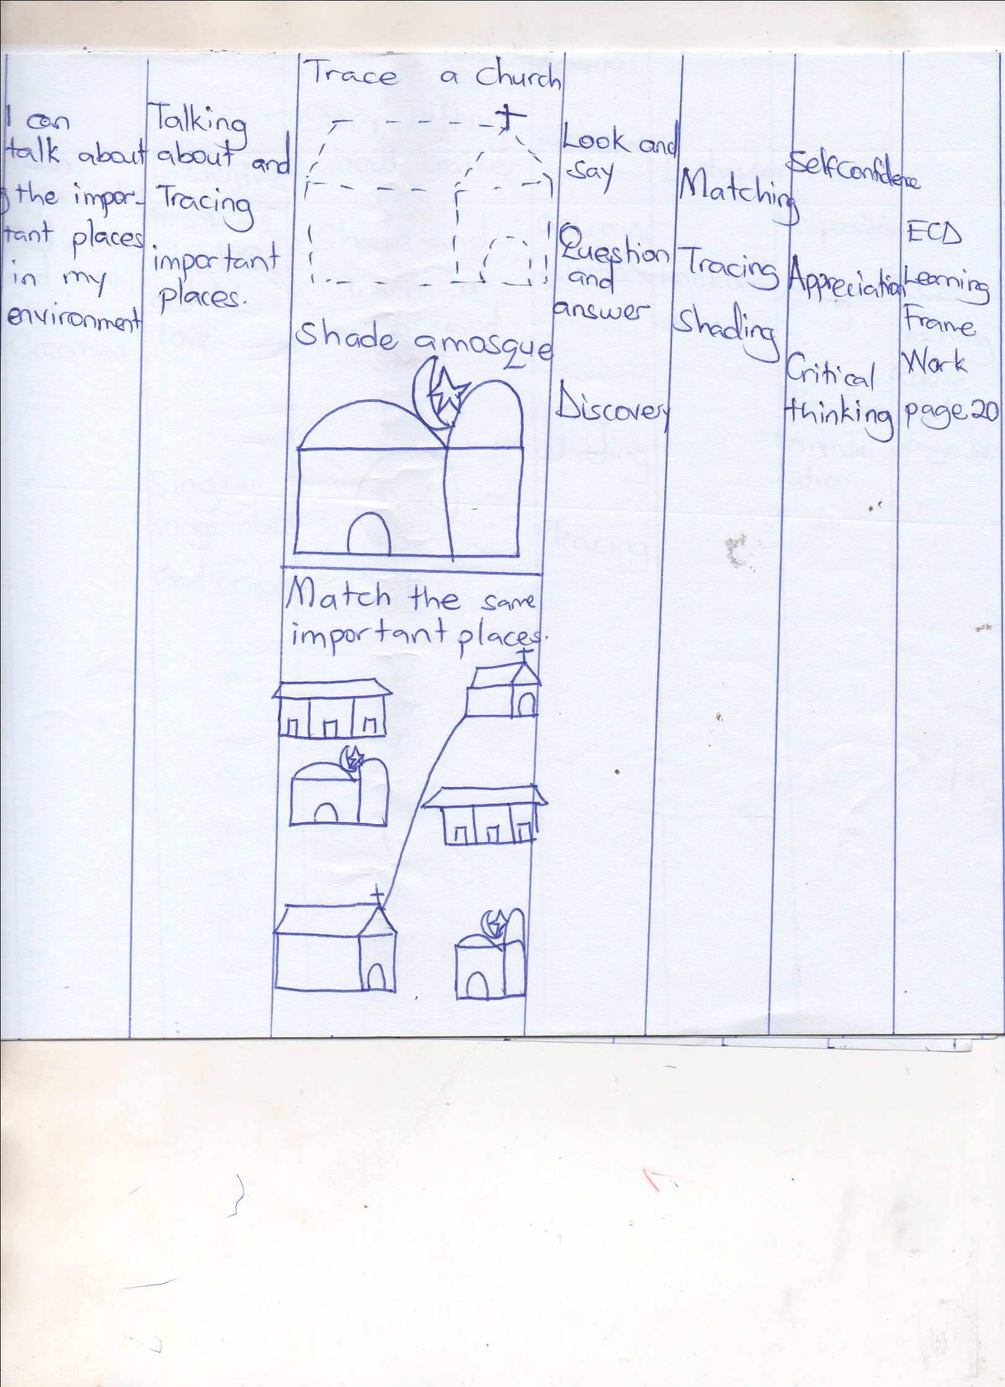

WEEK 8

PD1

I can talk about the important places in may environment.

Content

Match the same important places.

PD 2

Content

Trace a moon.

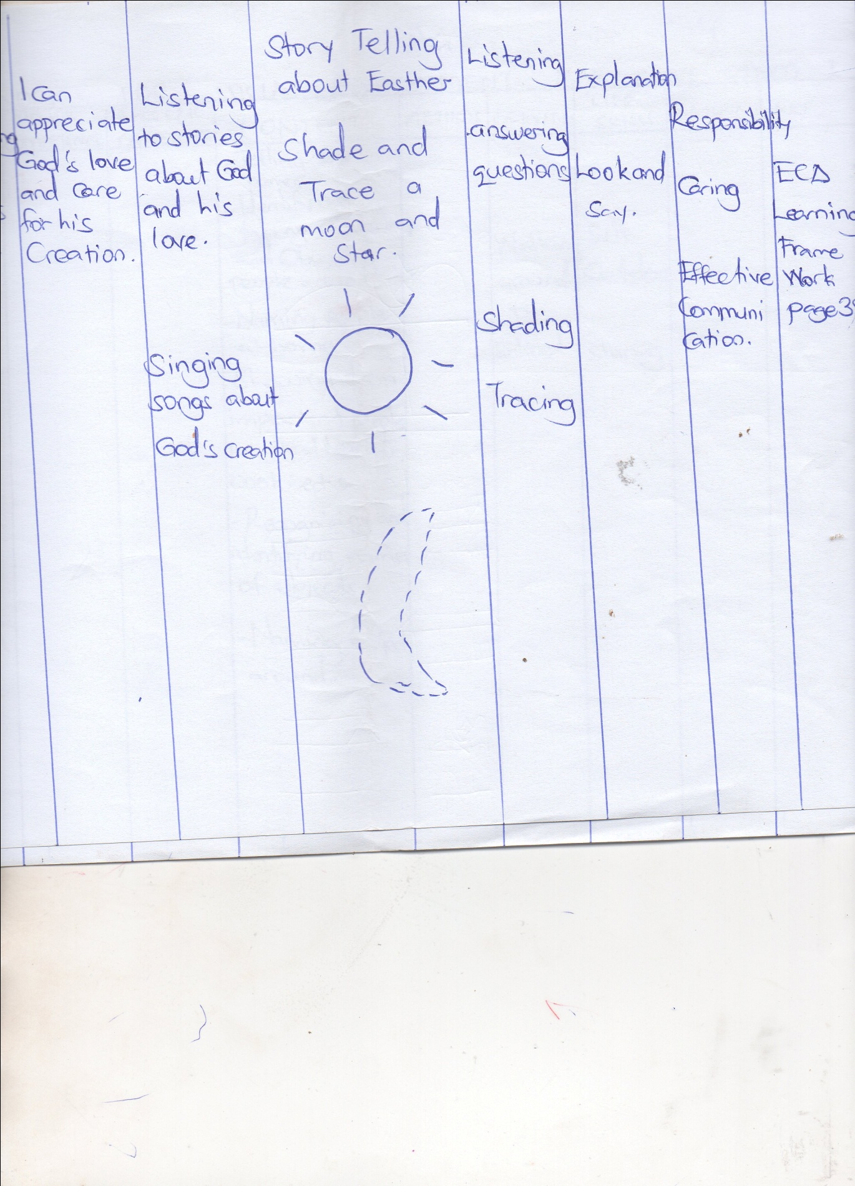

Shade a sun.

